Ref Project: IBC – Medeor PA 6100191 – E/Q Emergency Response Phase 2
BL: WASH 1.2.2 – Water Storage Containers Construction and Installation Works

Call for Tender
Part A – Instructions to bidders and invitation and
Publication Date: 23/11/2023
Tender Ref: IBC – Medeor PA6100191 – TR Component – WASH Intervention – 1.2.2
Water Storage Containers Construction and Installation Works in Gaziantep and Hatay Provinces
International Blue Crescent Relief and Development Foundation (IBC) has been implementing “Emergency Assistance to the E/Q affected population in Turkey and Syria” project funded by the Contracting Authority Action Medeor. The project aims: to respond to the most urgent basic needs immediately and providing primary basic needs to the earthquake affected people in Türkiye and Syria NW.

On the ground implementation of the works will be carried out based on a specific estimated amount and in accordance with the maximum eligible cost principle within the designated budget category within the reference project 6100191. The completion of the work will follow a sequential approach in the identified implementation areas both in Gaziantep and Hatay Provinces, by also ensuring that expenditures do not exceed the specified – allocated amount in the grant budget. Therefore, the number of implementation areas listed in the project scope may be subject to change (increase or decrease), a determination that will be made by the procurement awarding authority IBC.
Objective of the procurement is: To address the clean water access issues in the regions affected by the major earthquakes on February 6th in Kahramanmaraş and for the earthquake victims residing in Gaziantep and Hatay provinces, the provision, installation and operation of water tank systems is aimed, especially for the rural areas of the mentioned provinces. This includes ensuring the transportation or connection of these tank systems to city water networks, along with providing the necessary complementary equipment and material support for sustainability of the intervention.
In this regard, IBC is launching a competitive bidding and is requesting qualified bidders to provide detailed written offers for procurement and delivery of: Water Storage Containers Construction and Installation Works in Gaziantep and Hatay Provinces.
The compliance of all products and services to the relevant Turkish Standards Institute (TSE) standards is mandatory during the construction and completion stages of the project. The contractor is obliged to present TSE certificates and warranty documents for products related to water tanks and other materials, products to IBC before their shipment to the field. Products, materials without the submission of TSE certificates will not be accepted by IBC in the field.

1. Specification summary
- Description | Service and Supply Procurement on Water Storage Containers Construction, Installation, Operation, Monitoring and Testing.
- Product class/category | WASH Relief Measure – Water Storage Containers
- Made in (Service origin) | National/International
- Service/Product stage | Finished, functional and operate - Turnkey delivery
- Deliveries | On site in Gaziantep and Hatay Provinces mainly in Rural Parts
- Quantity | As per the offer form – PART B

2. Description of Work: The supply of water tanks in tonnages determined by IBC, including the assembly with appropriate conditions including concrete casting, the establishment of relevant water network and electrical connections, installation of electrical panels, provision of insulation, implementation of application tests under the supervision of IBC WASH teams, monitoring the functions of the water tanks and relevant apparatus under collaboration with IBC teams throughout the process, identification and rectification of potential disruptions, final inspection, control, and ultimate delivery.
3. Scope
WATER TANKS
The raw material for the water tanks to be procured will be polyethylene. The products will be odorless with a polyethylene structure, showing no toxic properties. They should have low-temperature resistance. The low water absorption feature should prevent the formation of mold, fungi, and similar issues without retaining water. It should provide electrical insulation. It should be sensitive to mechanical and chemical effects due to environmental stress. The supplied water should meet the following conditions in addition to the above-mentioned points:
- Corrosion resistance
- Chlorination
- Chemical and radiation cross-linking modification
- Electrical insulation
- Fiberglass-reinforced structure
- High strength
- Low melting point
- Low water absorption
- Flexibility, impact resistance
- Good radiation resistance and electrical properties
- It should have wear resistance.
- Water tanks with a polyethylene structure should offer long-term use and resistance against deformation.

Capacity and Dimensions of the Required Water Tanks
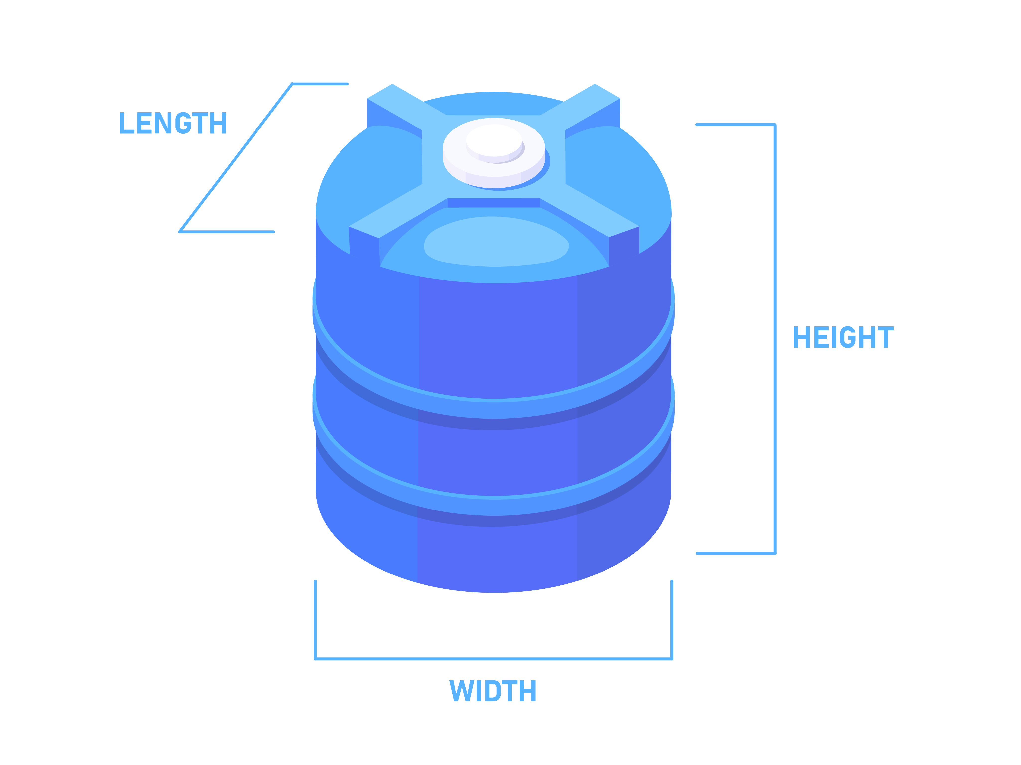
Order Nr |  | Capacity (lt) | Raw Material | Diameter/  Width (cm) | Height  (cm) | Mason | Lid Cover Diameter (cm)
1 | Vertical Cylinder Water Tank | 20.000 | Polyethylene | 280 | 330 | 2” | 44
2 | Vertical Cylinder Water Tank | 10.000 | Polyethylene | 235 | 265 | 1.1/4” | 44
3 | Vertical Cylinder Water Tank | 5.000 | Polyethylene | 200 | 250 | 1.1/4” | 39
4 | Vertical Cylinder Water Tank | 2.000 | Polyethylene | 130 | 167 | 1” | 39
5 | Vertical Cylinder Water Tank | 1.000 | Polyethylene | 86 | 188 | 1” | 32
6 | Vertical Cylinder Water Tank | 500 | Polyethylene | 61 | 167 | ¾” | 32

INSTALLATION of WATER TANKS
Water tanks are required to be sited and installed on level stable ground which has uniform compaction. Each pad must be oversize to the footprint of the dimensions of the water tank provided. Alternatively, water tanks ca n be sited on a reinforced concrete slab which must be approx 75-100mm thick that is level, flat and larger than the base of the tank. Overflow water must be piped away from the tank.
The installation of water tanks on the ground should be done as specified below. If the tank is to be installed at the same level as the ground, the ground should be leveled with sand, fine soil, or concrete with a thickness of 10 cm. The diameter of the leveled area should be 60-80 cm larger than the diameter of the tank. Do not place the tank on a sloped surface.

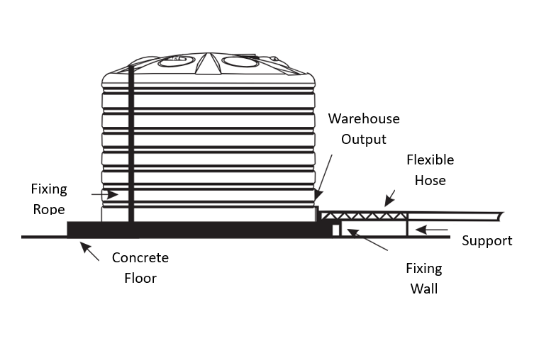

Required Essential Installation Remarks
Considering that polyethylene tanks expand when filled, it is required to ensure that the plumbing materials connected to water tanks are flexible. All connection components (sleeves, pipes, etc.) mounted on the water tanks should be installed independently. Installation should be provided at intervals on the tank from the floor (using dowels, concrete, etc.) to ensure stability.
When installing water tanks on a platform stand, consideration must be given to the fact that the full weight of the water tanks will be borne by the platform legs. In this case, the platform should be placed on a concrete surface. The platform legs should be securely fixed to the concrete, and the tank should be attached to the platform. This fastening should be designed to prevent irregular movements caused by the sloshing of water inside the tank, strong winds, or accidental contact. Water tanks should be lifted and installed onto the stand using a crane while they are empty. The plumbing used should be securely anchored to the stand.
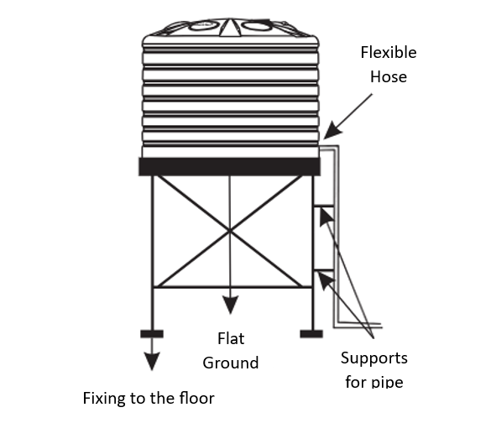
Considerations and Steps in the Installation of Water Tanks on the Stands
Considerations and steps to be taken into account during the installation of water tanks on a stand are as follows:
Platform Selection
Sturdy and level platforms capable of supporting the weight of the water tank must be ensured.
The surface of the platform must be ensured to be smooth and able to evenly distribute the entire load of the tank.
Ground Preparation
The ground beneath the platform must be prepared to withstand the weight of the water tank when full.
A concrete base must be prepared, as it can provide strong support against the weight of the tank.
Connection and Fastening
The water tank must be securely connected to the platform.
Platform legs must be securely anchored to the concrete, and a secure connection should be established to prevent irregular movements of the tank.
Assembly
Water tanks must be lifted and assembled while empty, using a crane or suitable lifting equipment.
Safety measures must be implemented during assembly, and appropriate equipment should be used.
Plumbing and Fastening
The plumbing used must be securely fastened to the stand.
Fastening the plumbing must be ensured for the stability during the tank's use.

Environmental Factors
The installation of the water tank and stand must take into account environmental factors. In this respect, adequate measures must be taken, especially against factors such as wind, rain, and sunlight, to minimize their impact on the tank's performance.
Unloading with a Forklift
Ensure that the forklift blades are straight and smooth.
Unloading with a Crane
During the unloading stage, hanging slings attached to the warehouse to perform the descent must be ensured.

METAL Works
The preparation, assembly, and installation of metal structures for carrying water tanks, which may vary in tonnages from 2, 5, 10, to 20 tons, and securing them in the respective areas. Appropriate types of paint should be used to prevent these supports from rusting, considering the influence of weather conditions and other factors. They should be painted and protected in a manner that ensures rust prevention for a minimum of 2 years and made ready for use.
CONCRETE Works
Concrete works should encompass the processes briefly outlined below, both in general and in terms of quality.
- All form works and shuttering in any form, shape and size. Making chamfered and/or curved edges, allowing for and making grooves and sleeves and using Tie Rods (Batant) for concrete walls; removal of forms and cleaning of all exposed tie wires and rods.
- Supplying, casting, and curing as per specifications.
- Concrete mix sampling, and testing.
- Preliminary installations for electrical, plumbing and floor drainage in floor slabs.
- Compaction and testing, and ground slabs.
- Supply and cast plain concrete under water tank min. 10cm thick.
WATER FAUCET
The network water pressure value is quite low in the region. Water tanks providing access to a water source must always be kept at a certain level. Hence, the planned water tank float valves – faucets should be connected to the water tank to regularly fill the required amount of water.
The water tank float – water faucets valve must ensure the continuous circulation of water within the tank and should be in an organized system. With the planned water float valves, when the required amount of water is used from the tank, clean water should be pumped in from a fresh water source. This circulation must ensure that the water inside the tank remains fresh and clean; the circulation should be operational. Water faucets must help prevent formations such as algae, odor, mold, and fungi, the accumulation of dust, soil, and dirt that may occur over time in the water must also be prevented.

The installation of the water float valve should be as follows:
- Begin by obtaining a component known as a double-sided reduction nipple.
- Use a nipple punch to perforate the water tank lid and place the nipple into position; the nipple material can be either metal or plastic. Two elbow pipes should be used for the nipple.
- The float valve pipe should be inserted into the inside elbow of the lid.
- The incoming water supply pipe should be mounted on the outside elbow, and the lid should be attached to the water tank.
OTHER INTEGRAL REQUIREMENTS
- Storage conditions for polyethylene tanks and plumbing connections must be considered for clean water storage.
- Since the tank can only be used at normal atmospheric pressure, proper ventilation must be ensured.
- Throughout all construction, assembly, and transportation stages, safety precautions must be taken in accordance with the Turkish Labor Law and workplace safety conditions.
- Connection components (sleeves, gaskets, caps, etc.) on the tank should not be excessively tightened. Flexible connections, allowing for expansion and contraction, should be used to protect the tank from vibrations coming from pumps or pipes.
Required Technical Key Aspects of Hydrophore – Pump System
Component
Hydrophore Pump: Hydrophore pumps must ensure consistent flow of water through the system within water tanks. The hydrophore capacity should be selected according to the specific needs of each implementation area.
Operation: The hydrophore pump must be activated when the pressure in the water supply system drops below a certain level, indicating a demand for water. The pump must draw water from the tank and pressurizes it before sending it through the water supply pipes.
Flow Rate (Debi): The rate at which water flows through the system, must be measured and specified in cubic meters per hour (m³/h).
Pressure: The force applied to the water, must be measured and specified in meters of water column (mWC) or bars (Bar).
Pump Body Material: Pump Body Material must be made of cast iron or stainless steel.
Impeller Material: The rotating component required for moving the water, materials must be brass.
Max. Operating Pressure: The maximum pressure the system must be handles with measurement monitoring in bars.
Functionality
The hydrophore system must ensure consistent water supply and pressure in the plumbing system.
The design must handle fluctuations in water demand and maintain a steady flow.
Implementation and Suitability
Selected products – hydrophores must be suitable in residential settings to provide pressurized water.
Safety Considerations
Safety measures and regulations, as per national standards and regulations, must be followed during the installation and operation of hydrophore systems at all times.

Sealants
The lap joint sealant must conform to rigorous technical requirements. It should be a single-component, moisture-cured, elastomeric sealant explicitly formulated for applications in water tanks. The sealant's composition must be well-suited for direct contact with network – transported water and hold certification meeting the Turkish National Standards for indirect additives.
Its primary application is to seal lap joints, bolt connections, and edge fillets, specifically for sheet notches, starter sheets, and other requisite areas. The sealant must exhibit superior adhesion properties to the fusion bond coating, minimal shrinkage upon curing, and versatility for both interior and exterior applications.

TESTING

After complete supply, installation and cleaning of the water tanks, the structure shall be tested for liquid tightness by filling tank to its overflow elevation. IBC shall furnish water required for testing at the time of tank erection completion, and at no charge to the contractor. Safe disposal of test water shall be the responsibility of the contractor.
To the attention of the bidders submitting proposals for this tender: The determination of other fittings, accessories, and materials to be prepared for use will be made by IBC during the field implementation stage.
Preliminary Site Visits
The site visits for a better understanding of the scope of the work, in addition to the technical and administrative specifications, and for assessing the alignment of the proposed bid with the qualitative and quantitative conditions of the work will take place on November 27, 2023, Monday, between 09:00 AM and 4:30 PM in Gaziantep Province, and on November 28, 2023, Tuesday, between 09:00 AM and 4:30 PM in Hatay Province. Prospective bidders will have the opportunity to conduct on-site visits during these times.
The starting point address and departure time for the site visits are as follows:
Islahiye District Yenimahalle TOKI Container Settlement Area IBC Campus Parking Lot (behind Islahiye AFAD Coordination Center), scheduled for:
- November 27, 2023, Monday, at 9:00 AM, and
- November 28, 2023, Tuesday, at 9:00 AM.
The IBC field team will assist bidders collectively during the site visits in terms of the locations related to the execution of the work. Bidders are required to be present in the field with their own vehicles for transportation.
Duration of the contract
- The contract will be valid for 2 months after the signing of the contract.
- The duration may vary depending on the work performed during the contract. The period may increase or decrease, and IBC does not commit to any specific duration.
Penalties
- A penalty of 0.005% of the contract amount will be applied if there is a delay or disruption in the entire job.
- A separate penalty of 0.0005% of the contract amount for each vehicle will be applied for each day of non-compliance with the specified obligations.

Invoices and Terms of Payment
The invoice(s) will be issued upon completion of the delivery of the work, testing phase, and post-testing monitoring processes. The delivery of the work and products will be overseen by the IBC project WASH technical personnel, field coordinator, project manager, and local administratively responsible. It will be documented through an official record following the inspection process of products/services.
At the time work delivery of goods and services the goods and service descriptions for invoicing will be detailed based on each construction, installation area, including concrete, pipe laying, metal works, buoy, hydrophore, stainless sink, etc.
The payment(s) will be made within 7 days of the following the invoices by the contractor, IBC to service provider’s bank account.
- Specific conditions
- Prices of the above procurement must include custom duties/taxes.
- Quantities are only indicative and may be subject to changes prior to contract award.
- Bidders are requested to fill in, sign, stamp and return Part A (Instruction to Bidders), Part B (Offer Form), and Part C (Ethical Declaration) according to IBC formats.
- All bidding documents must be filled in English and typed in electronic format against to handwriting typo errors.
- Offers only can be submitted in original formats in sealed envelopes.
- Bidders can apply for all lots.
- Prices should be submitted in Turkish Lira only.

- General Conditions
- The closing date of this tender is fixed on 29/11/2023 at 10:00 am Istanbul time and only in-hand deliveries can be accepted in IBC HQ Office – Procurement Department at the following address: Bağdat Caddesi No 467/9 34740 Suadiye – Istanbul, Türkiye
- Tenderers must sign, stamp, and return the Offer form according to IBC format.
- The offer to the call for tender will not result in the award of a contract.

- IBC is not liable of adhering to the public open tender procedure. IBC is free to hold a tender process or not.
- IBC reserves the right to cancel any tender, to reject any or all bids in whole or in part, and to award any contract.
- IBC may cancel the tender in the following situations:
  - When no qualitatively or financially worthwhile bid has been received or there has been no response at all.
  - The economic or technical parameters of the project have been fundamentally altered.
  - Exceptional circumstances or force majeure render normal performance of the project impossible.
  - All technically and administratively compliant bids significantly exceed the financial resources available. Provided this circumstance, IBC, at its sole discretion, may cancel and repeat the tender or continue the tender in form of an auction where the submitted offers may be underbid by the offering suppliers.
  - In no circumstances will IBC be liable for damages, whatever their nature (damages for the loss of profits) or relationship to the cancelation of the tender, even if IBC has been advised of the possibility of damages. The publication of a procurement notice does not commit IBC to implement the project announced.
IMPORTANT NOTE: To ensure that funds are used exclusively for humanitarian purposes and in accordance with Donor’s compliance requirements, all contract offers are subject to the condition that contractors do not appear on anti-terrorism lists, in line with IBC’s anti-terrorism policy. To this end, IBC reserves the right to carry out anti-terrorism checks on contractor, its board members, staff, volunteers, consultants, financial service providers and subcontractors.
- Required documents and way of submission
For your offer to be accepted by the IBC Tender Evaluation Committee, your offer must be submitted in the below described format containing the following.

Sealed Envelope 1: clearly marked with the words “formal documents” shall contain:
- Company’s official registration certificate obtained from the relevant authority,
- (OPTIONAL/IF APPLICABLE: Notarial certified partnership/joint venture agreement),
- Tax certificate (stating that company is officially registered with the relevant taxation authorities),
- Tender instruction document (PART A), Bidder’s Ethical Declaration (PART C) and Supply contract template (PART D) (signed and stamped by duly authorized company representative).
Sealed Envelope 2: clearly marked with the word “financial offer” shall contain:
- Financial Offer-Offer Form (PART B), quoted in Turkish Lira; signed by duly authorized company representative.
In the case of the formal documents (envelope 1) turn out to be incomplete or to be not in compliance with the defined criteria, the financial offer (envelope 2) will not be opened up by the Tender Evaluation Committee. In case the financial offer significantly exceeds the available project budget, your offer will be rejected and declared ineligible.

- Technical specification of supplies
The technical specifications of the items/products and kits are briefed-defined in PART B. In case your company in the same lot is not able to provide one or more of the required supplies at all or to provide one or more of the supplies only under the required quality standards or the required size and/or volume, you should absolutely refrain from submitting an offer to IBC.
- Contract conditions
7.1. Tender procedure
This tender does not commit IBC to pay for any costs incurred to the bidder for the preparation thereof, or to procure or contract services or goods.
IBC is not liable of adhering to the public open tender procedure. IBC is free to hold a tender process or not.
IBC reserves the right to cancel any tender, to reject any or all bids in whole or in part, and to award any contract.
IBC may cancel the tender in the following situations:
When no qualitatively or financially worthwhile bid has been received or there has been no response at all.
The economic or technical parameters of the project have been fundamentally altered.
Exceptional circumstances or force majeure render normal performance of the project impossible.
All technically and administratively compliant bids significantly exceed the financial resources available. Provided this circumstance, IBC, at its sole discretion, may cancel and repeat the tender or continue the tender in form of an auction where the submitted offers may be underbid by the offering suppliers.
Any bid submitted will be regarded as an offer made by the bidder and not as an acceptance by the bidder of an offer made by IBC.
The publication of a procurement notice does not commit IBC to implement the project announced.
7.2 Submission of documents and evaluation of bids:
The offers/bids shall only be submitted to IBC as defined in form PART B.
Please use offer submission envelope flaps.
IBC reserves the right, at its sole discretion, to consider as invalid or unacceptable any bid which is:
a) not clear;
b) incomplete in any material detail;
c) not presented in the requested form – and to accept or reject any amendments, withdraws and/or supplementary information submitted after the deadline for submission.
Any offers that do not fully comply with the specifications defined in form PART B, shall be rejected by the tender evaluation committee (In the case of the formal documents are incomplete or of incorrect nature, the financial offer (envelope 2) will not be opened).
The offers/bids must be received before the indicated deadline to be accepted by IBC. All bids received after the indicated deadline will be rejected.
Any bids submitted by mail or courier by so at the bidders’ risk and IBC takes no responsibility for the receipt of such bids.
All bids received by Email or Telefax will be rejected.
After the tender evaluation no information relating to the examination, clarification, evaluation and comparison of bids, or recommendations concerning the award of the contract can be disclosed.
Any attempt by a bidder to influence the tender evaluation committee in the process of examination, clarification, evaluation, and comparison of tenders, to obtain information on how the procedure is progressing or to influence IBC in its decision concerning the award of the contract will result in the immediate rejection of the tender.
Bids will be checked to determine if they comply with the essential requirements defined. A bid is deemed to comply if it satisfies all the conditions, procedures and specifications defined without substantially departing from or attaching restrictions with them. If a bid does not comply with defined requirements, it will be rejected immediately, no subsequent alterations to fulfill the compliance of the bid with the defined requirements shall annul the initial rejection of the bid.
Unsuccessful bidders will be informed about their unsuccessfulness in writing.
- Tender evaluation process
Given that your submitted offer fulfills the requested formal criteria, and the IBC Tender Evaluation Committee has rated your company as eligible to fulfill the requested tasks, upon warranting the technical specification, the financial offer is the only decisive criteria.
Awarding of contracts
IBC reserves the right to split awards.
IBC reserves the right to award a contract for a lesser or greater quantity than the total quantity of the bid.
This tender does not commit IBC to award a contract.
Successful bidders who are awarded contracts will be notified in writing or by the receipt of the written purchase order/contract.
The contract shall be in English language.
Project Contracting Authority, Action Medeor and any person authorized by this entity reserve the right to access the records and financial documentation of all implementing partners and (sub)-contractors in order to verify reported costs and conformity with donor procedures and requirements.
- Corrupt practices
All bidders and suppliers shall adhere to the highest ethical standards, both during the procurement process and throughout the performance of an awarded contract.
Bidders and their employees, officers, advisors, agent, or sub-contractors shall not engage in any collusive bidding or any other anti-competitive conduct.
- Exclusion criteria
Bidders or suppliers shall be excluded from participation in procurement procedures if:
- they are bankrupt or being wound up, are having their affairs administered by the courts, have entered into an arrangement with creditors, have suspended business activities, are the subject of proceedings concerning those matters, or are in any analogous situation arising from a similar procedure provided for in national legislation or regulations,
- they have been convicted of an offence concerning their professional conduct by a judgment which has the force of res judicata,
- they have been guilty of grave professional misconduct proven by any means,
- they have not fulfilled obligations relating to the payment of social security contributions or the payment of taxes in accordance with the legal provisions of the country in which they are established or in which the contract is to be implemented,
- they have been the subject of a judgment which has the force of res judicata for fraud, corruption, involvement in a criminal organization or any other illegal activity detrimental to IBC’s and Action Medeor’s financial interests,
- they are currently subject to an administrative penalty.
- Bidders’ declaration:
Bidders are required to declare:
- that they carry out their duties following the highest professional standards,
- that there is no conflict of interest with other recent commitments and contracts,
- that they respect ethical and environmental aspects such as working conditions, social rights, ethical transport and cargo and non-exploitation of children.

- The deadline for questions and answers
Bidders can send any quires that may arise with regards to the tender to the email address “procurementhq@ibc.org.tr” until the 27/11/2023, 17.00 am. IBC will provide the requested information to you as soon as possible, however, any delay in responding to your queries will not be considered as a reason for extending the deadline for the submission of your offer. Furthermore, please note that any information provided to you after reaching out to IBC for assistance, will simultaneously be provided to any other interested bidders that requested to receive the tender dossier.
- Force majeure
While each party shall make every effort to carry out its obligations under the terms of this agreement, neither party shall be held liable for any delay in performing or failure to perform any of its obligations under this agreement if such delay or failure is caused by force majeure, such as civil disorder, military action, natural disaster and other circumstances which are beyond the reasonable control of the party in question. In such event, the party will give immediate notice in writing to the other party of the existence, persistence and reasonably anticipated duration of such cause or event and of the likelihood of delay.
Annexes to this document
The following annexes are attached to this document:

- PART B: Offer Form with Technical Specifications
- PART C: Bidder’s ethical declaration
- PART D: Supply Contract Template
Sincerely yours,
International Blue Crescent Relief and Development Foundation (IBC)
Mevlüt Ezberci
IBC, Logistics and Administrative Department Supervisor

For Bidder’s Use
To be filled by Bidder (Compulsory)
I undersigned XXXXXXX the Bidder, agree with the instructions and general conditions of this Call for Tender.
Company Name: XXXXXXXXX
Authorized Representative Name: XXXXXXX
Stamp and Signature: ………………………………………………………………………………………………………………

Date: XX.XX.2023

